**Dr. Dennis Chmiel Speaking on;**

**State of the Industry:**

**The Evolving Companion Animal Marketplace**

**Registration 6-630pm**

**Dinner server 630pm**

**Lecture starting at 7pm**

**This lecture is open to all practice and office managers, veterinarians and owners.**



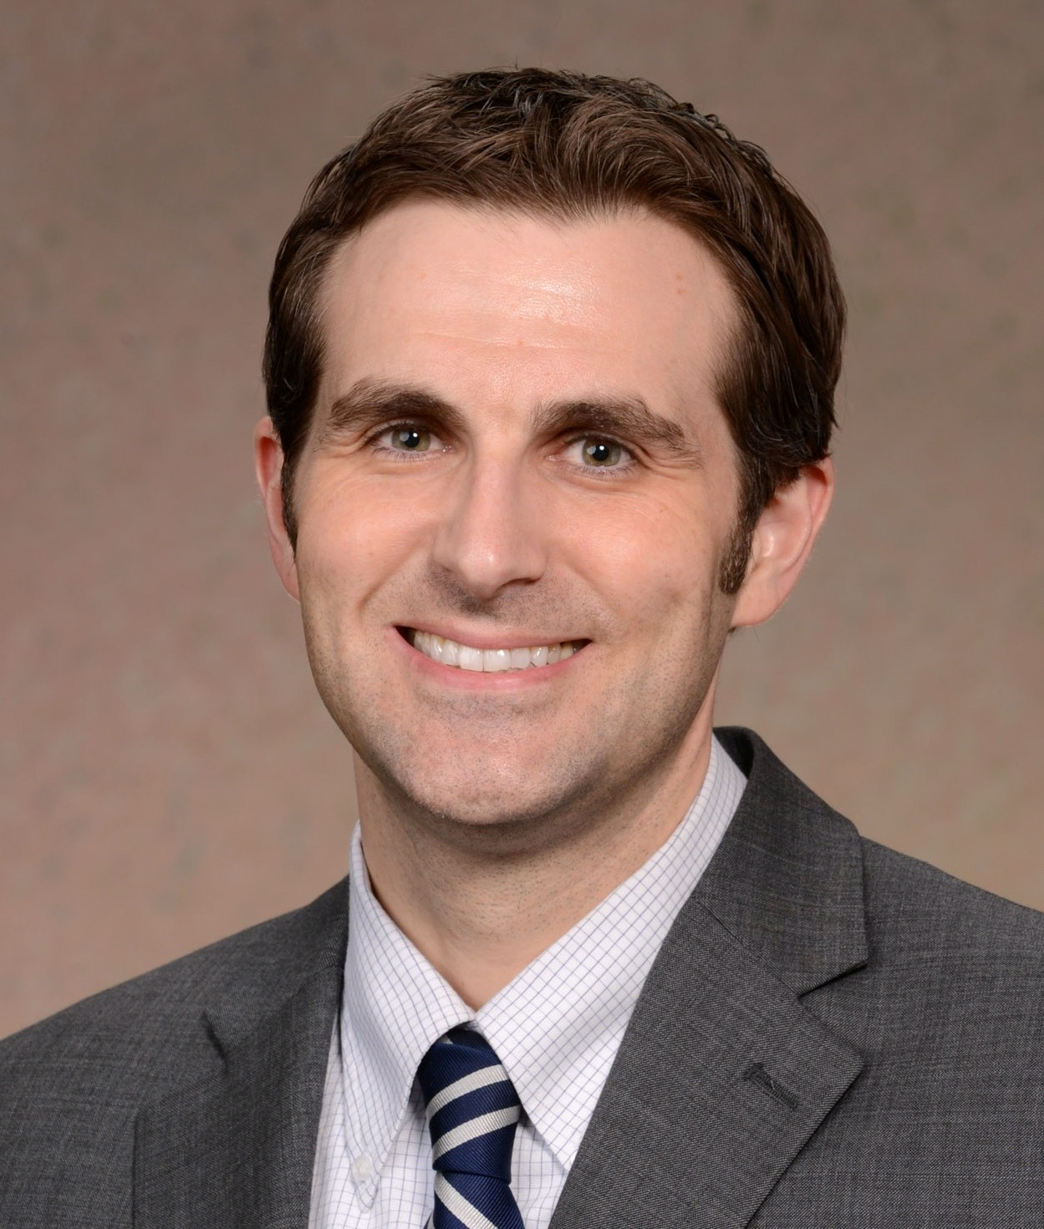

Wednesday June 3rd, 2015

At

Blue Event Center

4431 Easton Avenue

Bethlehem, PA 18020

RSVP by June 1st to

[Events@VCVREC.Com](mailto:Events@VCVREC.Com)

Please put the date and lecture title in subject line

** Along with **

**Presents a management lecture series by**

**Dr. Dennis Chmiel is the Veterinary Operations Manager of Veterinary Business Solutions for the Companion Animal Division of Zoetis. After 13 years in small animal practice, including 7 years managing a corporate hospital, Dr. Chmiel joined Pfizer Animal Health/Zoetis in 2011. As the Senior Area Technical Services Veterinarian, he provided science and pharmaceutical coaching support for the Zoetis small animal sales team and veterinarians throughout New England. He now serves as the principle scientific and business advisor to headquarters’ based U.S. commercial operations strategies for Lifelong Care, Profit Solver, PeopleFirst and the Pet Wellness Report. Some of his current speaking topics include: small animal veterinary market dynamics, practice management, health care communication, the Human-Animal Bond, and wellness. He is a 1998 graduate of Tufts University - School of Veterinary Medicine, and in 2011 received an Executive MBA from the Univ. of New Hampshire - Whittemore School of Business and Economics.**